Exam Domain Breakdown
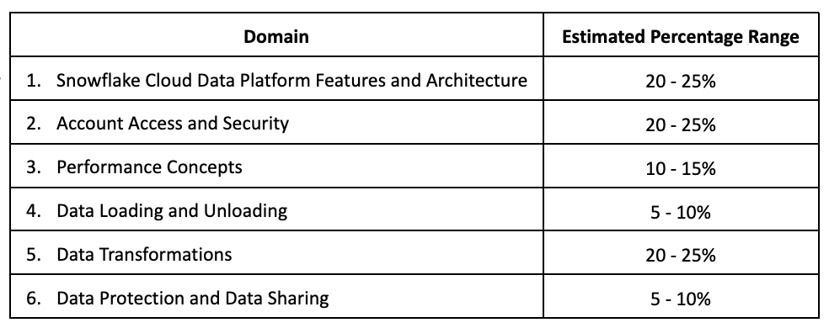

Domain 1.0: Snowflake Cloud Data Platform Features and Architecture
1.1 Outline key features of the Snowflake Cloud Data Platform.
- Elastic Storage
- Elastic Compute
- Snowflake’s three distinct layers
- Data Cloud/ Data Exchange/ Partner Network
- Cloud partner categories

1.2 Outline key Snowflake tools and user interfaces.
- Snowflake User Interfaces (UI)
- Snowsight
- Snowflake connectors
- Snowflake drivers
- SQL scripting
- Snowpark

1.3 Outline Snowflake’s catalog and objects.
- Databases
- Schemas
- Tables Types
- View Types
- Data types
- User-Defined Functions (UDFs) and User Defined Table Functions (UDTFs)
- Stored Procedures
- Streams
- Tasks
- Pipes
- Shares
- Sequences

1.4 Outline Snowflake storage concepts.
- Micro partitions
- Types of column metadata clustering
- Data Storage Monitoring
- Search Optimization Service

Domain 2.0: Account Access and Security
2.1 Outline compute principles.
- Network security and policies
- Multi-Factor Authentication (MFA)
- Federated authentication
- Single Sign-On (SSO)

2.2 Define the entities and roles that are used in Snowflake.
- Outline how privileges can be granted and revoked
- Explain role hierarchy and privilege inheritance

2.3 Outline data governance capabilities in Snowflake.
- Accounts
- Organizations
- Databases
- Secure views
- Information schemas
- Access history and read support

Domain 3.0: Performance Concepts
3.1 Explain the use of the Query Profile.
- Explain plans
- Data spilling
- Use of the data cache
- Micro-partition pruning
- Query history

3.2. Explain virtual warehouse configurations.
- Multi-clustering
- Warehouse sizing
- Warehouse settings and access

3.3 Outline virtual warehouse performance tools.
- Monitoring warehouse loads
- Query performance
- Scaling up compared to scaling out
- Resource monitors

3.4 Optimize query performance.
- Describe the use of materialized views
- Use of specific SELECT commands

Domain 4.0: Data Loading and Unloading
4.1 Define concepts and best practices that should be considered when loading data.
- Stages and stage types
- File size
- File formats
- Folder structures
- Adhoc/bulk loading using the Snowflake UI

4.2 Outline different commands used to load data and when they should be used.
- CREATE PIPE
- COPY INTO
- GET
- INSERT/INSERT OVERWRITE
- PUT
- STREAM
- TASK
- VALIDATE

4.3 Define concepts and best practices that should be considered when unloading data.
- File formats
- Empty strings and NULL values
- Unloading to a single file
- Unloading relational tables

4.4 Outline the different commands used to unload data and when they should be used.
- LIST
- COPY INTO
- CREATE FILE FORMAT
- CREATE FILE FORMAT … CLONE
- ALTER FILE FORMAT
- DROP FILE FORMAT
- DESCRIBE FILE FORMAT
- SHOW FILE FORMAT

Domain 5.0: Data Transformation
5.1 Explain how to work with standard data.
- Estimating functions
- Sampling
- Supported function types
- User-Defined Functions (UDFs) and stored procedures

5.2 Explain how to work with semi-structured data.
- Supported file formats, data types, and sizes
- VARIANT column
- Flattening the nested structure

5.3 Explain how to work with unstructured data.
- Define and use directory tables
- SQL file functions
- Outline the purpose of User-Defined Functions (UDFs) for data analysis

Domain 6.0: Data Protection and Data Sharing

6.1 Outline Continuous Data Protection with Snowflake.
- Time Travel
- Fail-safe
- Data Encryption
- Cloning
- Replication

6.2 Outline Snowflake data sharing capabilities.
- Account types
- Data Marketplace and Data Exchange
- Private data exchange
- Access control options
- Shares

Recommended Training
As preparation for this exam, we recommend a combination of hands-on experience, instructor-led training, on demand training courses and the utilization of self-study assets.
Instructor-Led Course recommended for this exam:
Snowflake Fundamentals
Paid Self Study recommended for this exam:
SnowPro Core Certification Preparation Course
Free Self Study recommended for this exam:
SnowPro Core Study Guide
Snowflake Hands on Essentials & Level Up Series
Snowflake in 20 Minutes

